Case Study – 7
Title / Aim :- To demonstrate the events handling in javascript
- Access and manipulate form elements using js.
- Validate user inputs(e.g. Email, empty fields).
- Use various form events (submit,change,focus)
Case Study:
Create the following html form and use required js and events in a given form (first name, last name, email, birthday, password, reenter password, agree to the terms and conditions)

Software/Tools Required :-
- Visual Studio Code (VS Code)
- Google Chrome / Any Web Browser
- HTML
- JavaScript

CODE:-
Index.html
<!DOCTYPE html>
<html lang="en">
<head>
<meta charset="UTF-8">
<meta name="viewport" content="width=device-width, initial-scale=1.0">
<title>Dance Workshop Registration</title>
<link rel="stylesheet" href="style.css">
</head>
<body>
<div class="container">
<header>
<div class="icon">💃</div>
<h1>Dance Workshop</h1>
<p>Register now and dance with us!</p>
</header>
<form id="registrationForm">
<h2>📝 Registration Form</h2>
<!-- First Name -->
<div class="form-group">
<label for="firstName">First Name</label>
<input
type="text"
id="firstName"
placeholder="Enter your first name"
>
<small id="firstNameError"></small>
</div>
<!-- Last Name -->
<div class="form-group">
<label for="lastName">Last Name</label>
<input
type="text"
id="lastName"
placeholder="Enter your last name"
>
<small id="lastNameError"></small>
</div>
<!-- Email -->
<div class="form-group">
<label for="email">Email Address</label>
<input
type="email"
id="email"
placeholder="example@gmail.com"
>
<small id="emailError"></small>
</div>
<!-- Birthday -->
<div class="form-group">
<label for="birthday">Date of Birth</label>
<input
type="date"
id="birthday"
>
<small id="birthdayError"></small>
</div>
<!-- Dance Style -->
<div class="form-group">
<label for="danceStyle">Dance Style</label>
<select id="danceStyle">
<option value="">
Select a dance style
</option>
<option value="Hip Hop">
Hip Hop
</option>
<option value="Classical">
Classical
</option>
<option value="Contemporary">
Contemporary
</option>
<option value="Bollywood">
Bollywood
</option>
<option value="Salsa">
Salsa
</option>
<option value="Jazz">
Jazz
</option>
</select>
<small id="danceStyleError"></small>
</div>
<!-- Password -->
<div class="form-group">
<label for="password">Create Password</label>
<input
type="password"
id="password"
placeholder="Enter password"
>
<small id="passwordError"></small>
</div>
<!-- Confirm Password -->
<div class="form-group">
<label for="confirmPassword">
Re-enter Password
</label>
<input
type="password"
id="confirmPassword"
placeholder="Re-enter password"
>
<small id="confirmPasswordError"></small>
</div>
<!-- Terms -->
<div class="terms">
<input
type="checkbox"
id="terms"
>
<label for="terms">
I agree to the Terms and Conditions
</label>
</div>
<small id="termsError"></small>
<!-- Submit -->
<button type="submit">
💃 Register for Workshop
</button>
<!-- Success Message -->
<div id="successMessage"></div>
</form>
</div>
<script src="script.js"></script>
</body>
</html>

Style.css
* {
box-sizing: border-box;
margin: 0;
padding: 0;
font-family: Arial, sans-serif;
}
body {
background: #797477;
min-height: 100vh;
display: flex;
justify-content: center;
padding: 40px 20px;
color: #1f2937;
}
.container {
width: 100%;
max-width: 550px;
background: rgb(182, 180, 180);
border-radius: 18px;
overflow: hidden;
box-shadow: 0 8px 25px rgba(0, 0, 0, 0.12);
}
/* Header */
header {
background: #db2777;
color: white;
text-align: center;
padding: 35px;
}
.icon {
font-size: 50px;
}
header h1 {
font-size: 32px;
margin: 10px 0 5px;
}
header p {
font-size: 15px;
}
/* Form */
form {
padding: 30px;
}
form h2 {
margin-bottom: 25px;
color: #be185d;
}
/* Form Groups */
.form-group {
margin-bottom: 18px;
}
label {
display: block;
margin-bottom: 7px;
font-weight: bold;
color: #374151;
}
input[type="text"],
input[type="email"],
input[type="date"],
input[type="password"],
select {
width: 100%;
padding: 12px;
border: 1px solid #d1d5db;
border-radius: 8px;
font-size: 15px;
outline: none;
background: white;
}
/* Focus Event */
input:focus,
select:focus {
border-color: #db2777;
box-shadow: 0 0 0 3px #fce7f3;
}
/* Error Messages */
small {
display: block;
margin-top: 5px;
font-size: 13px;
color: #dc2626;
}
/* Terms */
.terms {
display: flex;
align-items: center;
gap: 8px;
margin-top: 20px;
}
.terms input {
width: 17px;
height: 17px;
}
.terms label {
margin: 0;
font-weight: normal;
}
/* Button */
button {
width: 100%;
padding: 14px;
margin-top: 22px;
border: none;
border-radius: 8px;
background: #db2777;
color: white;
font-size: 16px;
font-weight: bold;
cursor: pointer;
}
button:hover {
background: #be185d;
}
/* Success */
#successMessage {
margin-top: 20px;
text-align: center;
color: #16a34a;
font-weight: bold;
}
/* Mobile */
@media (max-width: 500px) {
body {
padding: 20px 10px;
}
form {
padding: 22px;
}
header h1 {
font-size: 27px;
}
}

Script.js
// ---------------------------------------------
// ACCESS FORM ELEMENTS
// ---------------------------------------------
const form =
document.getElementById("registrationForm");
const firstName =
document.getElementById("firstName");
const lastName =
document.getElementById("lastName");
const email =
document.getElementById("email");
const birthday =
document.getElementById("birthday");
const danceStyle =
document.getElementById("danceStyle");
const password =
document.getElementById("password");
const confirmPassword =
document.getElementById("confirmPassword");
const terms =
document.getElementById("terms");
// ---------------------------------------------
// FOCUS EVENT
// ---------------------------------------------
firstName.addEventListener("focus", function () {
firstName.style.backgroundColor = "#fdf2f8";
});
// --------------------------------------------
// CHANGE EVENTS
// ---------------------------------------------
// Email validation when email changes
email.addEventListener("change", function () {
validateEmail();
});
// Password validation when password changes
password.addEventListener("change", function () {
validatePassword();
});
// Confirm password validation
confirmPassword.addEventListener("change", function () {
validateConfirmPassword();
});
// Dance style change
danceStyle.addEventListener("change", function () {
const error =
document.getElementById("danceStyleError");
if (danceStyle.value === "") {
error.textContent =
"Please select a dance style.";
} else {
error.textContent =
"Selected: " + danceStyle.value;
error.style.color = "green";
}
});
// Terms change
terms.addEventListener("change", function () {
const error =
document.getElementById("termsError");
if (terms.checked) {
error.textContent =
"Terms accepted ✓";
error.style.color = "green";
} else {
error.textContent =
"You must agree to the terms.";
error.style.color = "red";
}
});
// ---------------------------------------------
// EMAIL VALIDATION
// ---------------------------------------------
function validateEmail() {
const error =
document.getElementById("emailError");
const emailPattern =
/^[^\s@]+@[^\s@]+\.[^\s@]+$/;
if (email.value.trim() === "") {
error.textContent =
"Email is required.";
error.style.color = "red";
return false;
}
if (!emailPattern.test(email.value)) {
error.textContent =
"Please enter a valid email.";
error.style.color = "red";
return false;
}
error.textContent =
"Valid email ✓";
error.style.color = "green";
return true;
}
// ---------------------------------------------
// PASSWORD VALIDATION
// ---------------------------------------------
function validatePassword() {
const error =
document.getElementById("passwordError");
if (password.value.trim() === "") {
error.textContent =
"Password is required.";
error.style.color = "red";
return false;
}
if (password.value.length < 6) {
error.textContent =
"Password must contain at least 6 characters.";
error.style.color = "red";
return false;
}
error.textContent =
"Password is valid ✓";
error.style.color = "green";
return true;
}
// ---------------------------------------------
// CONFIRM PASSWORD
// ---------------------------------------------
function validateConfirmPassword() {
const error =
document.getElementById("confirmPasswordError");
if (confirmPassword.value.trim() === "") {
error.textContent =
"Please re-enter your password.";
error.style.color = "red";
return false;
}
if (password.value !== confirmPassword.value) {
error.textContent =
"Passwords do not match.";
error.style.color = "red";
return false;
}
error.textContent =
"Passwords match ✓";
error.style.color = "green";
return true;
}
// ---------------------------------------------
// FORM SUBMIT EVENT
// ---------------------------------------------
form.addEventListener("submit", function (event) {
// Prevent page refresh
event.preventDefault();
let isValid = true;
// First Name
if (firstName.value.trim() === "") {
document.getElementById("firstNameError")
.textContent =
"First name is required.";
isValid = false;
} else {
document.getElementById("firstNameError")
.textContent = "";
}
// Last Name
if (lastName.value.trim() === "") {
document.getElementById("lastNameError")
.textContent =
"Last name is required.";

isValid = false;
} else {

document.getElementById("lastNameError")
.textContent = "";
}
// Email
if (!validateEmail()) {

isValid = false;
}
// Birthday
if (birthday.value === "") {
document.getElementById("birthdayError")
.textContent =
"Date of birth is required.";

isValid = false;
} else {
document.getElementById("birthdayError")
.textContent = "";
}
// Dance Style
if (danceStyle.value === "") {
document.getElementById("danceStyleError")
.textContent =
"Please select a dance style.";
document.getElementById("danceStyleError")
.style.color = "red";
isValid = false;
}
// Password
if (!validatePassword()) {
isValid = false;
}
// Confirm Password
if (!validateConfirmPassword()) {
isValid = false;
}
// Terms
if (!terms.checked) {
document.getElementById("termsError")
.textContent =
"You must agree to the Terms and Conditions.";
document.getElementById("termsError")
.style.color = "red";
isValid = false;
}
// ----------------------------------------
// FINAL RESULT
// -----------------------------------------
const success =
document.getElementById("successMessage");
if (isValid) {
success.textContent =
"🎉 Registration successful! See you at the workshop!";
success.style.color = "green";
// Reset form after successful registration
form.reset();
} else {
success.textContent =
"Please correct the errors above.";
success.style.color = "red";
}
});

Output :-
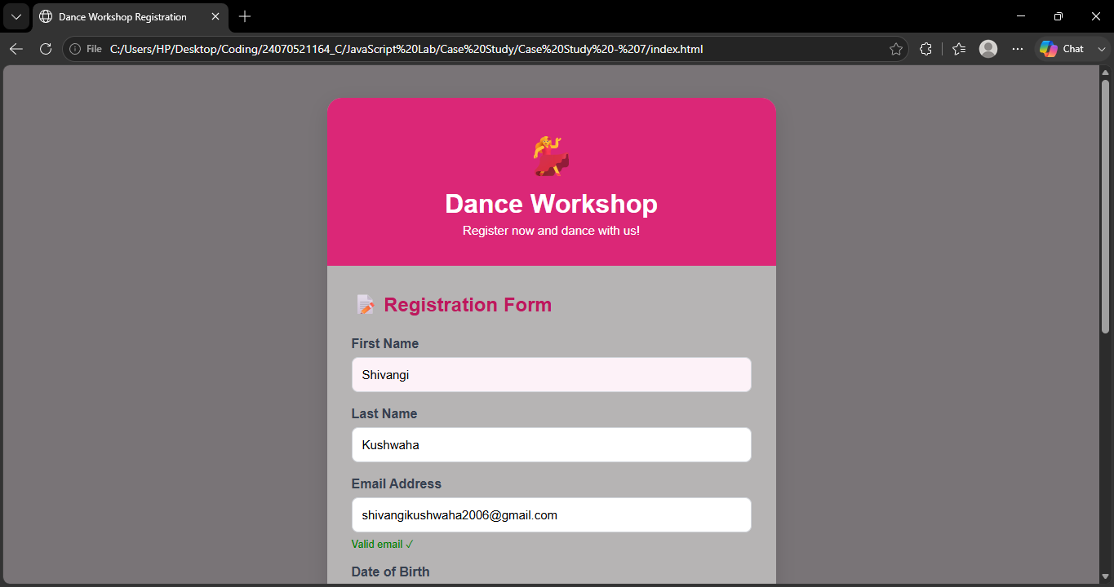

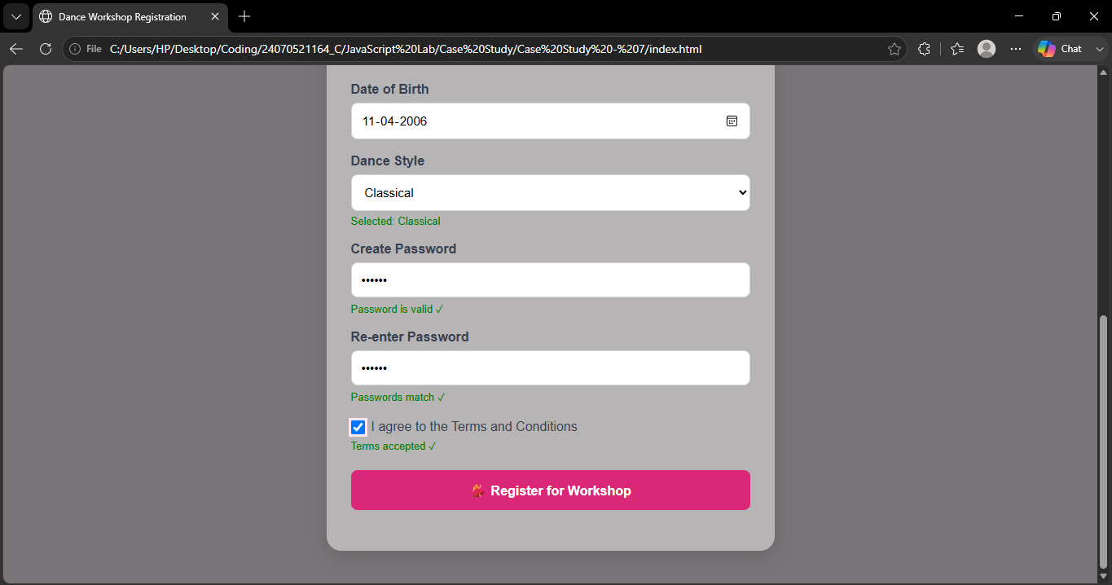

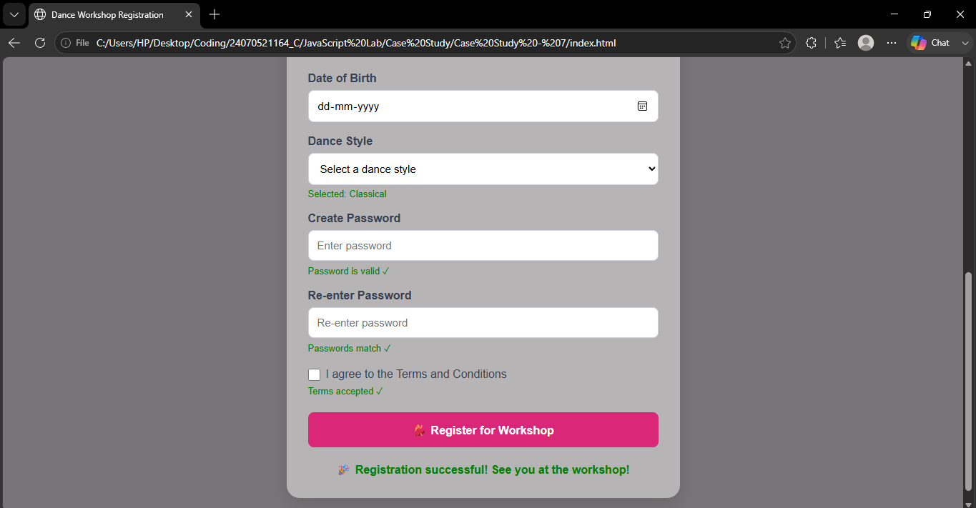

Result / Conclusion :-
The Dance Workshop Registration Form was successfully developed using HTML, CSS, and JavaScript. JavaScript events such as focus, change, and submit were implemented to handle user interactions. The form validates empty fields, email format, password length, password matching, and terms acceptance. DOM methods were used to access form elements and dynamically display validation messages .Thus, the experiment provided practical understanding of event handling, DOM manipulation, and form validation in JavaScript.

